Lesson 1: Node JS Introduction and Features , callbacks, Non Blocking I/O

**Node.js Introduction:**

Node.js is an open-source server side runtime environment built on Chrome's V8 JavaScript engine. It provides an event driven, non-blocking (asynchronous) I/O and cross-platform runtime environment for building highly scalable server-side application using JavaScript.

Node.js can be used to build different types of applications such as command line application, web application, real-time chat application, REST API server etc. However, it is mainly used to build network programs like web servers, similar to PHP, Java, or ASP.NET.

Node.js was written and introduced by Ryan Dahl in 2009.

Node.js official web site: [https://nodejs.org](https://nodejs.org/)

Node.js on github: <https://github.com/nodejs/node>

Node.js community conference [http://nodeconf.com](http://nodeconf.com/)

## Features of Node.js

Following are some of the important features that make Node.js the first choice of software architects.

* **Asynchronous and Event Driven** − All APIs of Node.js library are asynchronous, that is, non-blocking. It essentially means a Node.js based server never waits for an API to return data. The server moves to the next API after calling it and a notification mechanism of Events of Node.js helps the server to get a response from the previous API call.
* **Very Fast** − Being built on Google Chrome's V8 JavaScript Engine, Node.js library is very fast in code execution.
* **Single Threaded but Highly Scalable** − Node.js uses a single threaded model with event looping. Event mechanism helps the server to respond in a non-blocking way and makes the server highly scalable as opposed to traditional servers which create limited threads to handle requests. Node.js uses a single threaded program and the same program can provide service to a much larger number of requests than traditional servers like Apache HTTP Server.
* **No Buffering** − Node.js applications never buffer any data. These applications simply output the data in chunks.
* **License** − Node.js is released under the [MIT license](https://raw.githubusercontent.com/joyent/node/v0.12.0/LICENSE)

Where to Use Node.js?

Following are the areas where Node.js is proving itself as a perfect technology partner.

* I/O bound Applications
* Data Streaming Applications
* Data Intensive Real-time Applications (DIRT)
* JSON APIs based Applications
* Single Page Applications

Advantages of Node.js

1. Node.js is an open-source framework under MIT license. (MIT license is a free software license originating at the Massachusetts Institute of Technology (MIT).)
2. Uses JavaScript to build entire server side application.
3. Lightweight framework that includes bare minimum modules. Other modules can be included as per the need of an application.
4. Asynchronous by default. So it performs faster than other frameworks.
5. Cross-platform framework that runs on Windows, MAC or Linux

Node JS Process Model:

Traditional Web Server Model

In the traditional web server model, each request is handled by a dedicated thread from the thread pool. If no thread is available in the thread pool at any point of time then the request waits till the next available thread. Dedicated thread executes a particular request and does not return to thread pool until it completes the execution and returns a response.

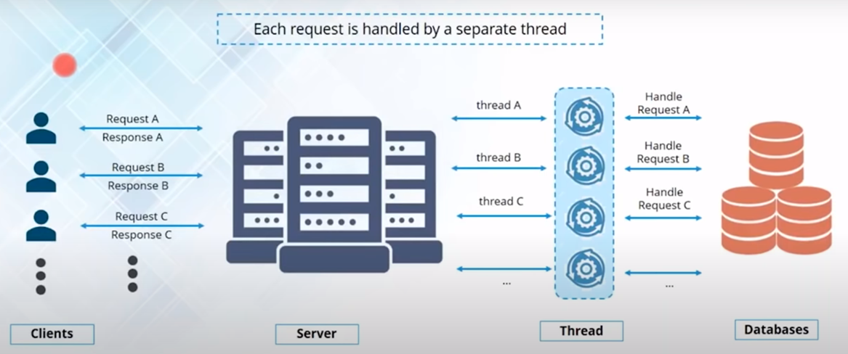

Node.js Process Model

Node.js processes user requests differently when compared to a traditional web server model. Node.js runs in a single process and the application code runs in a single thread and thereby needs less resources than other platforms. All the user requests to your web application will be handled by a single thread and all the I/O work or long running job is performed asynchronously for a particular request. So, this single thread doesn't have to wait for the request to complete and is free to handle the next request. When asynchronous I/O work completes then it processes the request further and sends the response.

An event loop is constantly watching for the events to be raised for an asynchronous job and executing callback function when the job completes. Internally, Node.js uses [libev](http://software.schmorp.de/pkg/libev.html) for the event loop which in turn uses internal C++ thread pool to provide asynchronous I/O.

The following figure illustrates asynchronous web server model using Node.js.

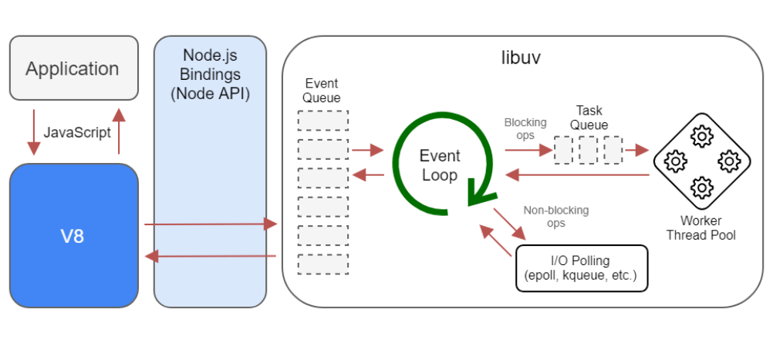 Node.js Process Model

Node.js process model increases the performance and scalability with a few caveats. Node.js is not fit for an application which performs CPU-intensive operations like image processing or other heavy computation work because it takes time to process a request and thereby blocks the single thread.

NodeJS Success Stories:

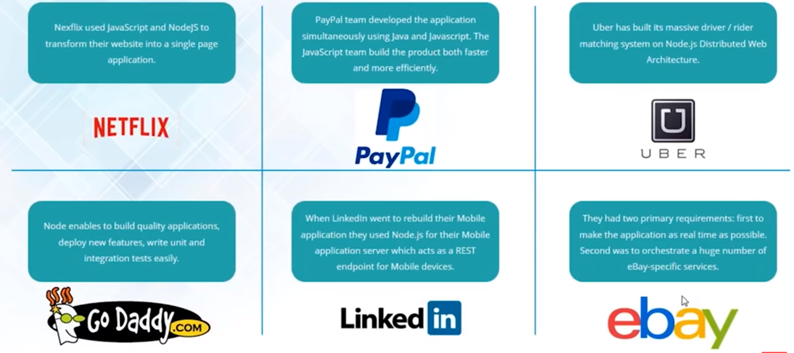

To know more success stories, look into the below link

<https://thinkmobiles.com/blog/node-js-app-examples/>

Callbacks:

Callback is an asynchronous equivalent for a function. A callback function is called at the completion of a given task. Node makes heavy use of callbacks. All the APIs of Node are written in such a way that they support callbacks.

For example, a function to read a file may start reading file and return the control to the execution environment immediately so that the next instruction can be executed. Once file I/O is complete, it will call the callback function while passing the callback function, the content of the file as a parameter. So there is no blocking or wait for File I/O. This makes Node.js highly scalable, as it can process a high number of requests without waiting for any function to return results.

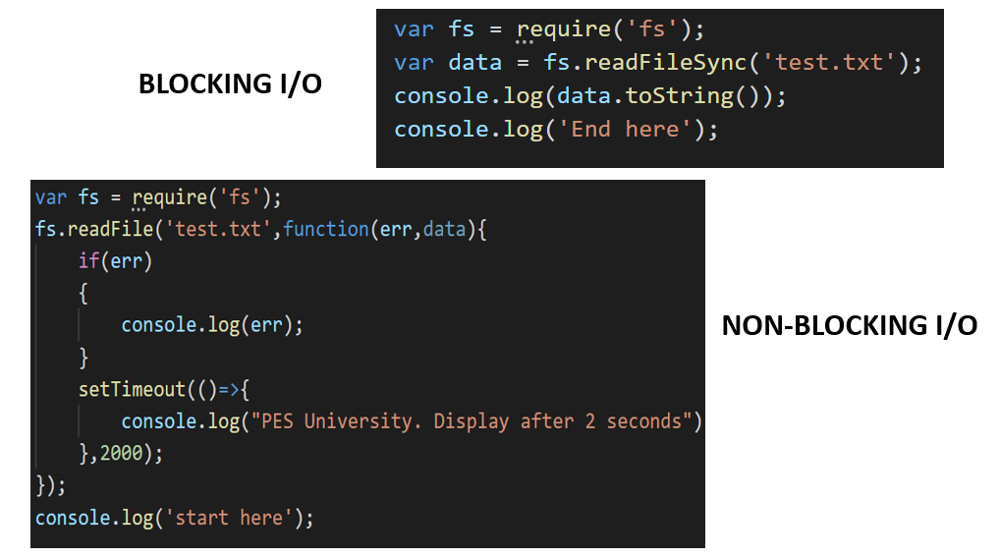

These two examples explain the concept of blocking and non-blocking calls.

* The first example shows that the program blocks until it reads the file and then only it proceeds to end the program.
* The second example shows that the program does not wait for file reading and proceeds to print "Start here" and at the same time, the program without blocking continues reading the file.

Thus, a blocking program executes very much in sequence. From the programming point of view, it is easier to implement the logic but non-blocking programs do not execute in sequence. In case a program needs to use any data to be processed, it should be kept within the same block to make it sequential execution.